Online Banking Application


Team:
Richard Schneider
Ly Randle
Puala Salazar
Marcus Wong
Ahmed Boukhousse

Content:
- Introduction……………………………………………………………………………1
- Quick Start Guide…………………………………………………………………….2
- System Requirements……………………………………………………………….3
- Main Scenarios of Use……………………………………………………………….4

Introduction:
Online banking has become an essential part of our lives because of its many benefits. It allows users to access a record of their accounts at any time from anywhere, pay bills, and transfer money. Banking from the comfort of your sofa, at any time of the day or night, makes everything you do with your finances a bit easier for free.

Our online banking application has been sponsored by Commerce Bank. It is a web application that gives users the ability to login to their accounts, access to the user account history and transactions from anywhere. This is the quickest way to see whether a transaction has cleared a user account. Make and update transactions, and set notifications when a transaction was made out of state or when a transaction exceeds a certain dollar amount.

- Quick Start Guide:
The following is a guide to quickly and seamlessly begin banking from your phone or desktop. It outlines system requirements, a quick start and using the application itself.

2.1. Quick Start
- Open the software on your device
- Navigate to the login screen using the ‘Sign In’ button at the top left
- Enter your email and password then hit the continue button below to be taken to all of your account information

2.2 Using the Application:

Login: Click on the Sign in button, and provide the user’s credentials and click on continue to be taken to the user’s account.
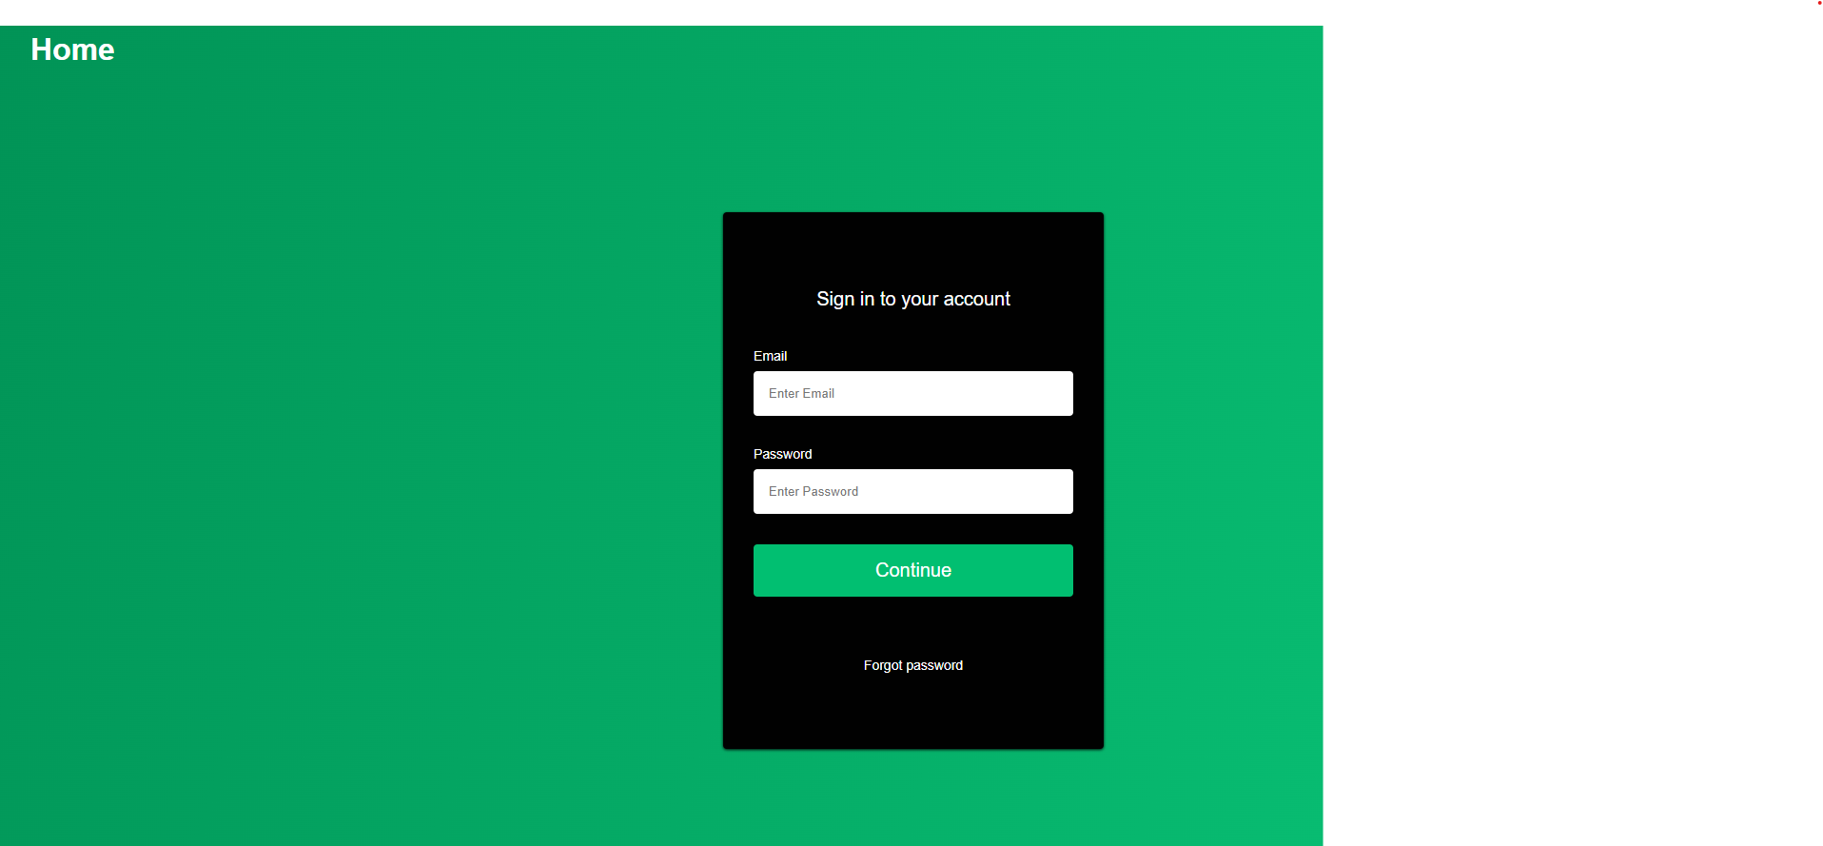
Notifications: After signing in you will be shown your accounts along with notification that have not been read.
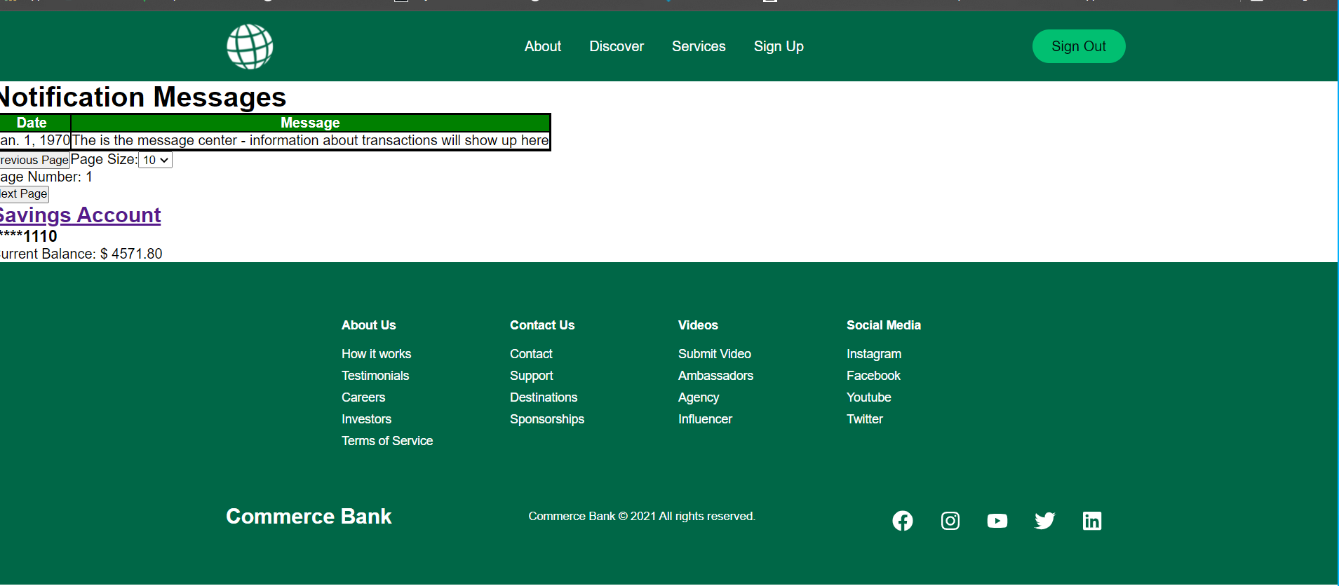

Transactions: You can click on the name of one of the accounts to navigate to the transactions for that account.
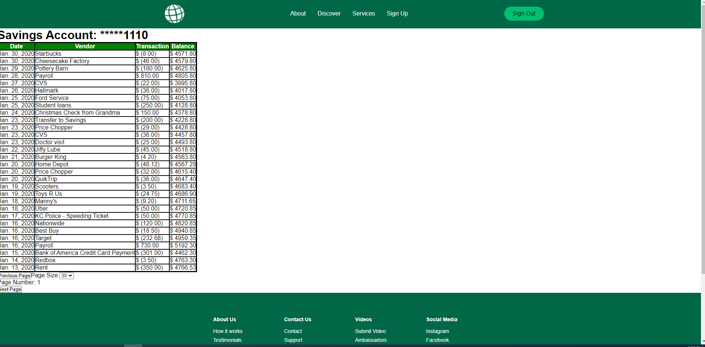

You can also navigate through all transactions and change the number shown on each page by using the navigation buttons at the button of the transaction list.

Log out: Once you are finished looking at your banking information, you can navigate back to the main page using the ‘Sign out’ button at the top left of the page
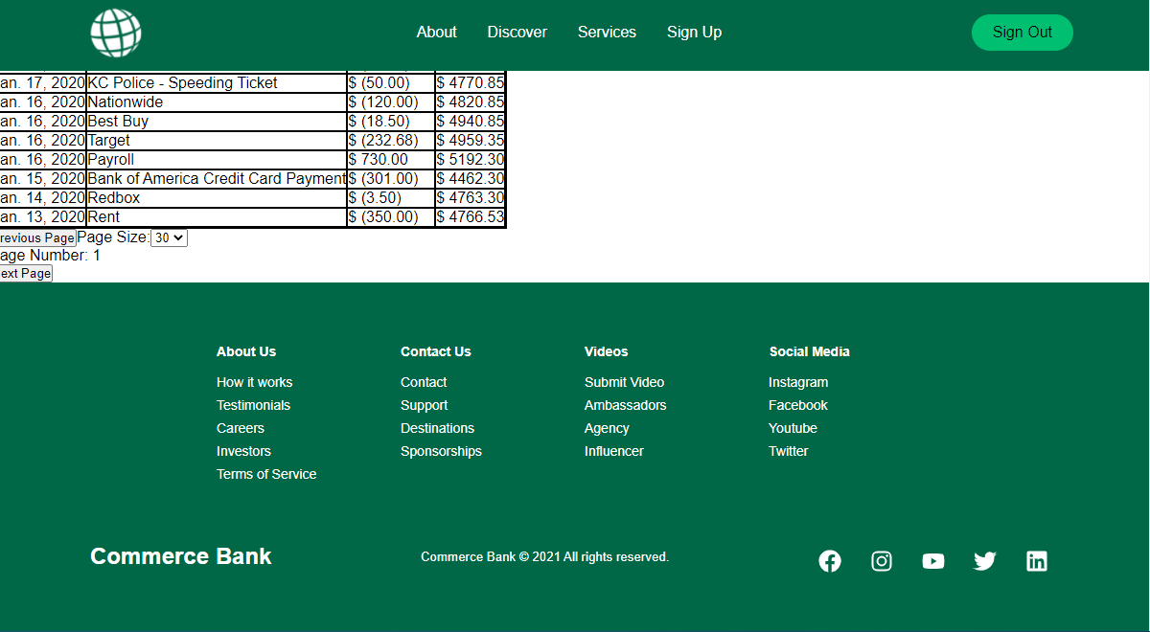

3. System requirements
- Internet access and a browser
- Javascript enabled
- A bank account with the bank

- Main Scenarios of use
4.1 User login by clicking on sign in option and providing email and password
4.2 If password and username are correct they are directed to their account
4.3 If password or username are not correct, an error message is displayed
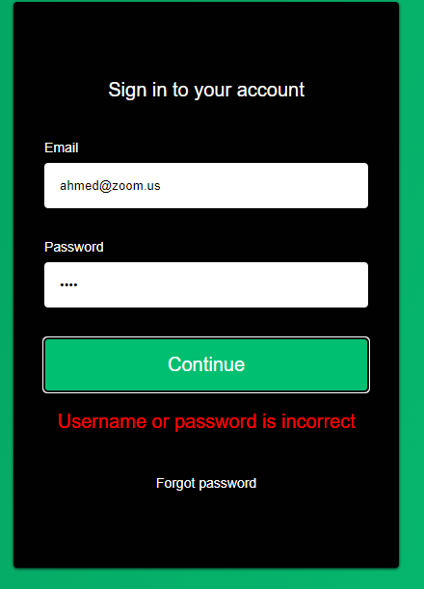
4.4 The app is mobile friendly and it should work smoothly on mobile device

